NAME: NAGELLA ASHOK
ID: SWUID2026226211
Story screenshots:
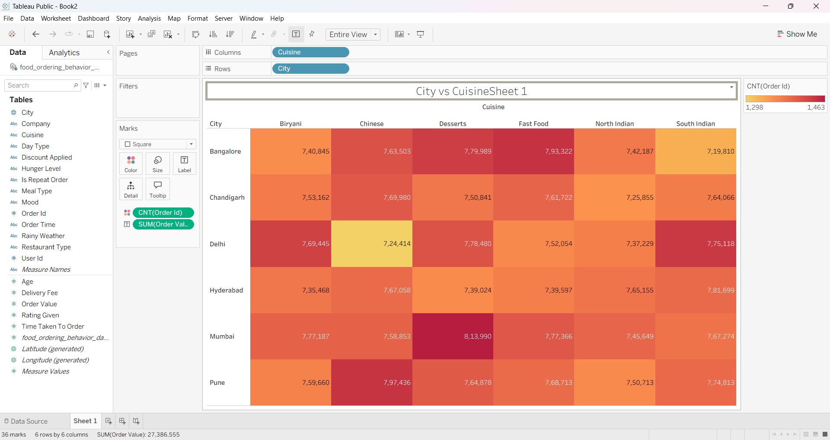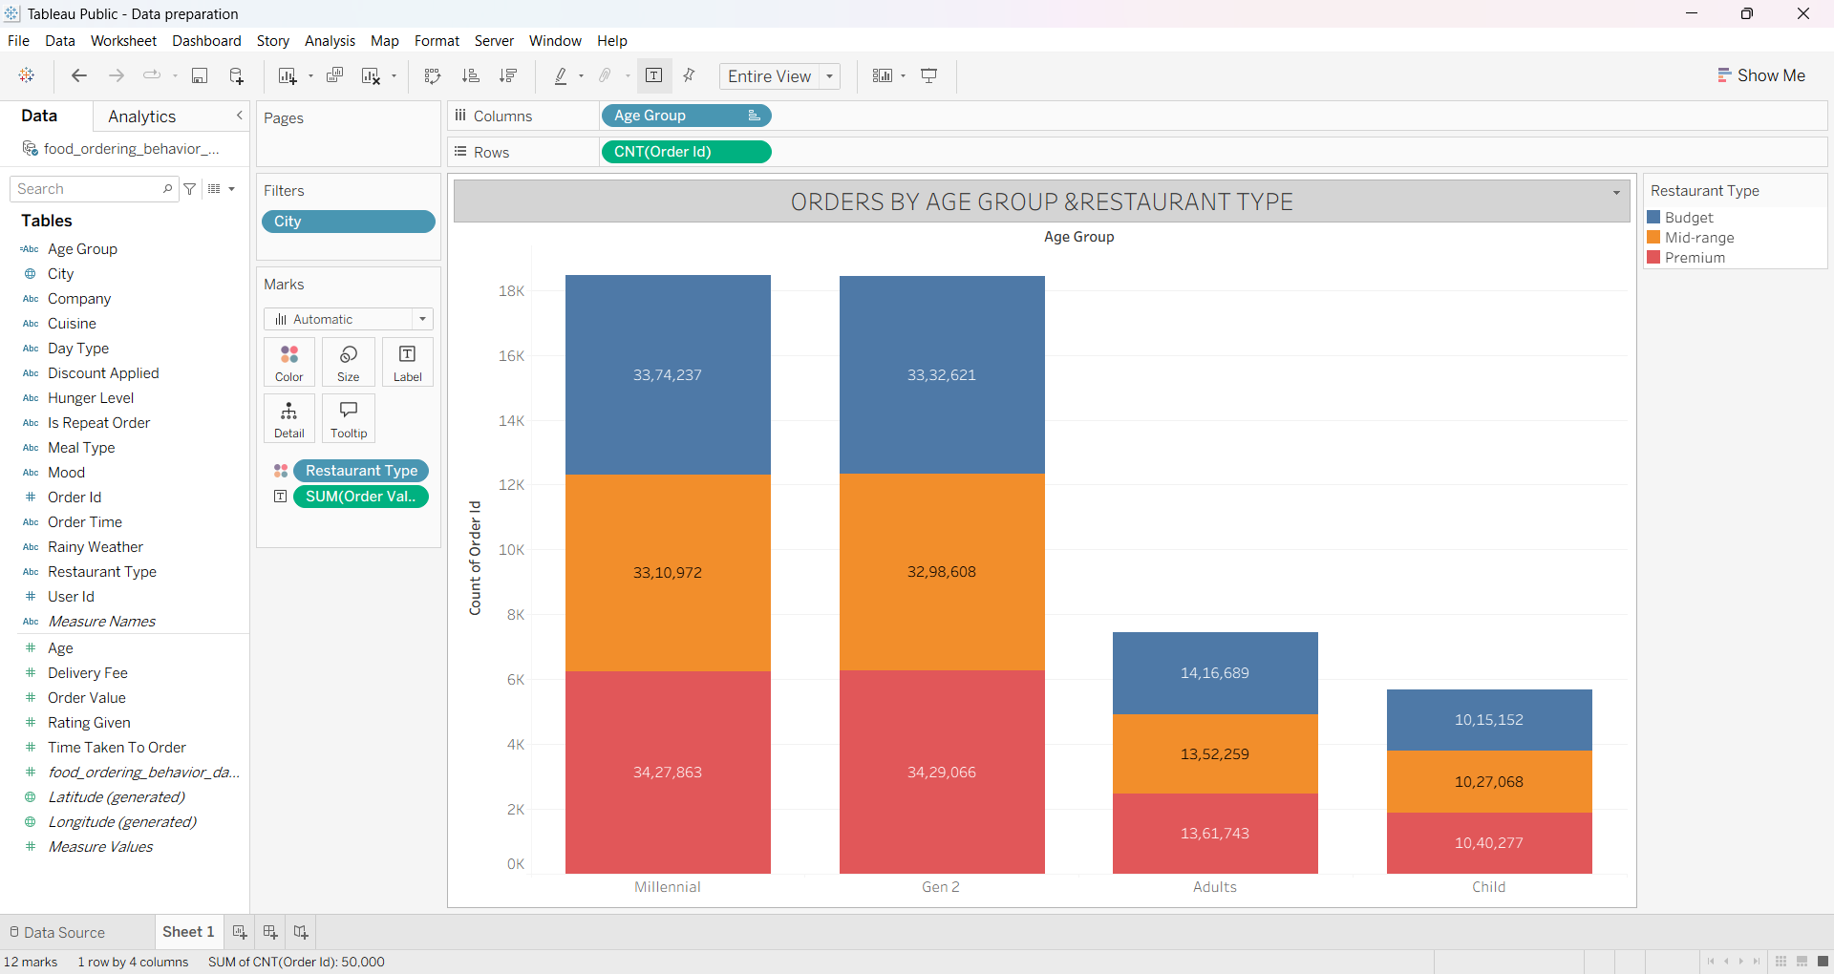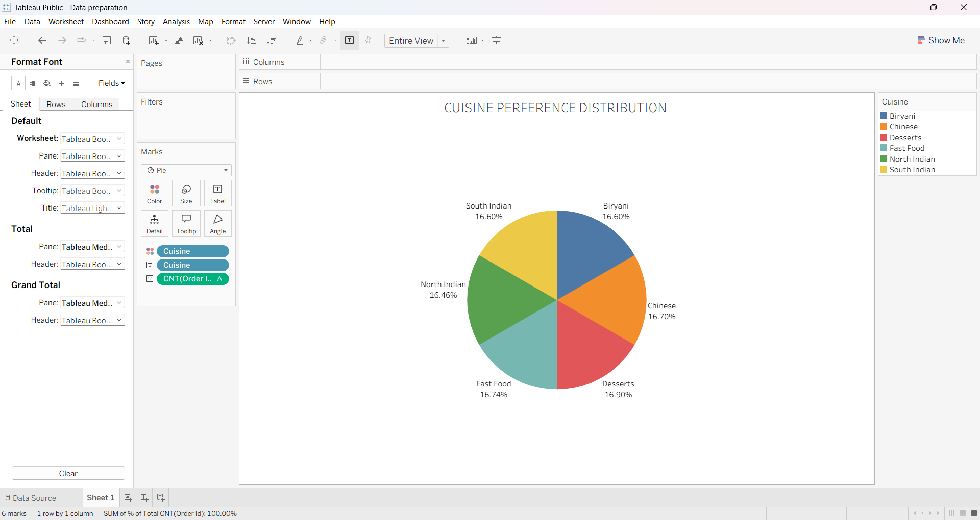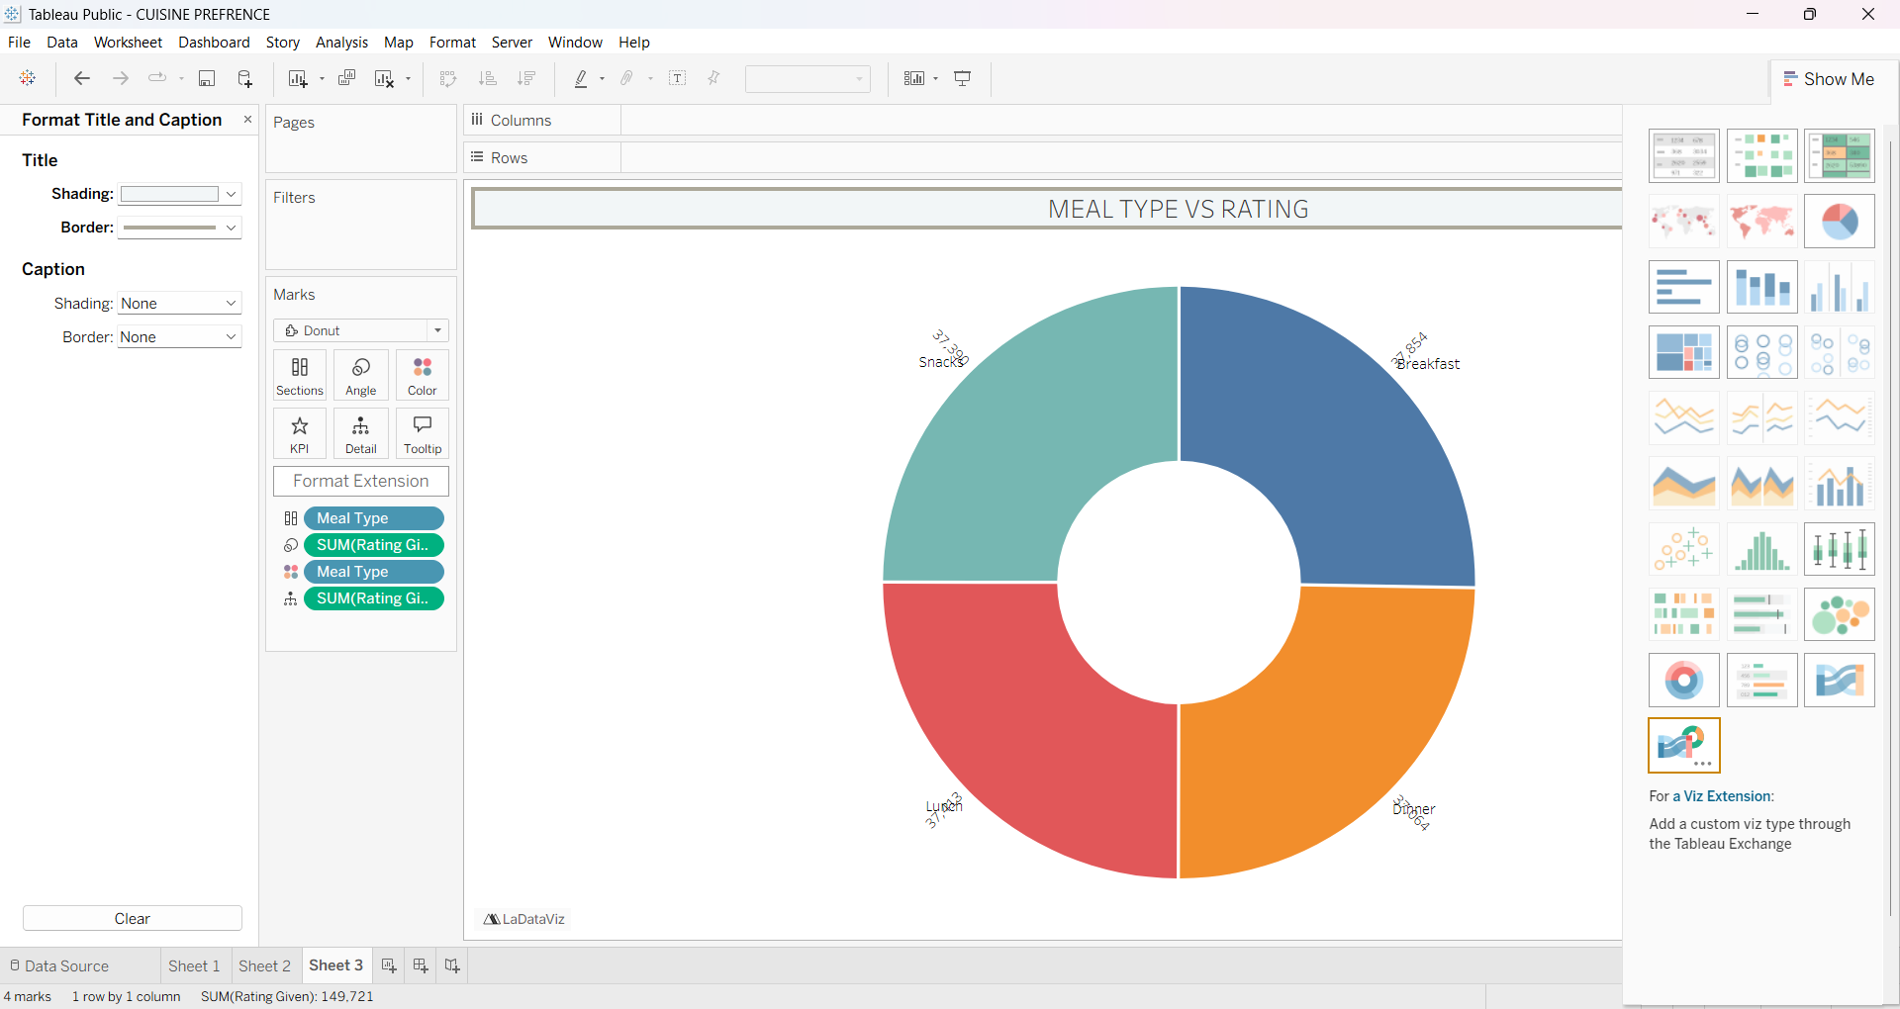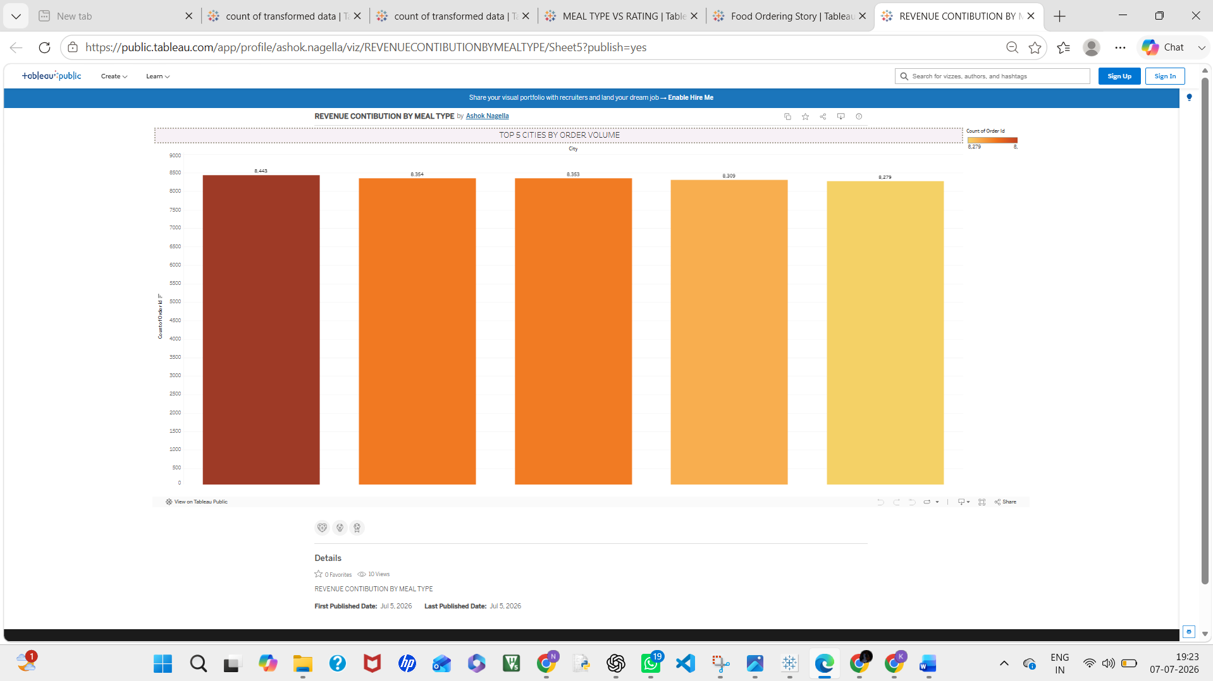
Tableau public link:
https://public.tableau.com/app/profile/ashok.nagella/viz/REVENUECONTIBUTIONBYMEALTYPE/Sheet5?publish=yes

